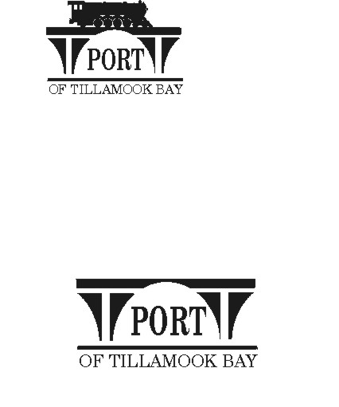

AGENDA – SPECIAL MEETING
POTB BOARD OF COMMISSIONERS
PORT OFFICE, 4000 BLIMP BLVD., TILLAMOOK – CONFERENCE ROOM
MONDAY, DECEMBER 22, 2025, AT 1:00 PM

https://us02web.zoom.us/j/84110978865?pwd=ZLvNXNYreLJ15rWbv5xDLyYLaxHgbb.1

Any comments or written testimony, if allowed, may be submitted to mbradley@potb.org up to 11:00 am on the afternoon of the meeting.

- 1:00 Call to Order, Recognition of Persons Present

- Update and discussion of assessment and emergency repairs to Hangar B

- Local Contract Review Board declaration of Emergency

- If needed: Executive Session per ORS 192.660 (2) (e) to discuss Real Property Transactions

