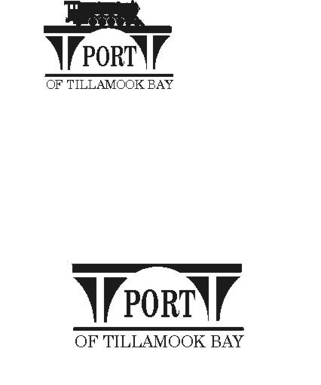

##### NOTICE AND DRAFT AGENDA

**BOARD OF COMMISSIONERS WORKSHOP**

**MONDAY, NOVEMBER 18, 2024, APPROX 3:00 - 4:30 P.M.**

**FOLLOWING REGULAR BOARD MEETING**

**4000 BLIMP BLVD., SUITE 100, TILLAMOOK**

**CONFERENCE ROOM**

<https://us02web.zoom.us/j/87943647416?pwd=t9521blh5YdqIo32csam02TJaDl1JG.1>

1. Call to Order and Recognition of Persons Present
2. Workshop Discussion on General Manager Contract Update – Jim Knight, SDAO Senior Consultant
3. Adjourn