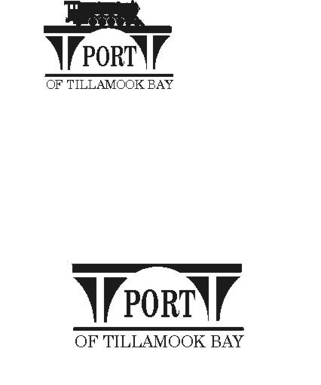

##### AGENDA

**POTB BOARD OF COMMISSIONERS**

**REGULAR MONTHLY MEETING**

**PORT OFFICE, 4000 BLIMP BLVD., TILLAMOOK – CONFERENCE ROOM**

**WEDNESDAY OCTOBER 16, 2024 AT 6:00 P.M.**

<https://us02web.zoom.us/j/84077124356?pwd=KzRTVFUwbGxjS1hiZ205SzJwS3hUZz09>

*Any comments or written testimony, if allowed, may be submitted to* [*mbradley@potb.org*](mailto:mbradley@potb.org) *up to 3:00 pm on the afternoon of the meeting*

1. 6:00 Call to Order, Recognition of Persons Present, and Public Comment for Items Not on the Agenda (2-minute limit, or as Board President Desires)
2. 6:05 Friends of Tillamook Air Museum – Gene, request to be on agenda
3. 6:20 Office Administrator Report – Pami Boomer
4. 6:25 Consent Agenda **(Action)**
   * 1. Minutes for September 23, 2024 Regular Meeting
5. 6:30 Air Museum Director Report – Rita Welch
6. 6:45 Discussion and Consideration of Annual Employee Holiday Bonuses **(Action)**
7. 6:50 Manager’s Written Report and Discussion - Michele Bradley
8. 7:00 Board Updates
   1. Baertlein – hangar funding option discussion

9) Communications

* 1. **Board workshop: Tuesday, October 22, 2024, 2:00 – 3:30 pm**
  2. Board meeting: Wednesday, November 20, 2024, 6:00 pm
  3. Closed Thanksgiving Holiday: November 28 and 29
  4. Board meeting: Wednesday, December 18, 2024, 6:00 pm
  5. Closed Christmas Holiday: December 25
  6. Closed New Years Day

1. HOLD: Executive Session per ORS 192.660 (2)(h) To consult with counsel concerning the legal rights and duties of a public body with regard to current litigation or litigation likely to be filed; and ORS 192.660 (2) (e) to discuss Real Property Transactions
2. Adjourn